The Girl Scout Chorus
Proudly presents:
The Golden Eaglet

A Story of a Girl Scout in 1918
Join us for a musical journey based on a film that promoted the benefits of a Girl Scout summer camp experience. Putting her hiking, marching, swimming and semaphore skills to good use, Margaret is transformed from bored town girl to model citizen.
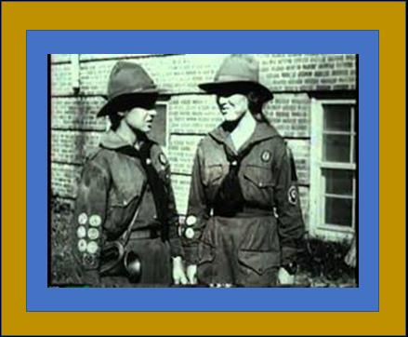
Invited: Families and Scouts
Where: Peterson Center
Camp Ilchester
When: Sunday, April 7th, 3-4 PM
Cost: One non-perishable food item
Questions call Pat at 410-233-5337 or
Email: GSCMChorus@yahoo.com

-------------------------tear off--------------------
Name: _____________________
Address: ________________________zip______
Phone: ___________ E-mail: ________________
Number of attendees: ______
Please bring one non-perishable food item per person
Please return registration to: Kelly Smith
209 Kenwood Ave.
Catonsville, MD 21228
Food Donations supporting “FOOD ON THE 15th”
PARENT/GUARDIAN PERMISSION FORM

NAME OF EVENT………………...The Golden Eaglet Musical Theater
PURPOSE…………………………. Golden Eaglet Story performed by the Chorus
WHO WILL BE ATTENDING……Girl Scouts of all ages, family, and friends
DATE………………………………Sunday, April 7, 2019
LOCATION………………………..Peterson Activity Center, Camp Ilchester, Ellicott City
MEETING PLACE………………...Peterson Center
START…….3 PM SHARP (arrive around 2:30-2:45 to park
STOP TIME. 4 PM
COST……………………………… non-perishable food item(s) for “Food on the 15th”
METHOD OF TRAVEL……….….Parents’ cars
WHAT TO WEAR…………………Girl Scout uniform
ADULT IN CHARGE……..Pat Disharoon FIRST AIDER…….….Kelly Smith
EMERGENCY MEDICAL FACILITY: St. Agnes Hospital PHONE: 410-368-6000
EMERGENCY CONTACT: PHONE:
**Troops/groups traveling to and from Girl Scout events must adhere to the driving/seatbelt/First Aid standards and checklists in SAFETY-WISE.

PLEASE KEEP TOP HALF FOR YOUR RECORDS

RETURN BOTTOM HALF OF FORM TO LEADER by

My daughter _______________________ has my permission to participate in the field trip to Camp Ilchester.
I agree that my daughter is in good health and may participate in this activity. I give my permission for medical treatment if necessary. I understand that Girl Scout activity insurance is secondary to any personal insurance I may have. I agree that she will not attend this event if she should become ill or exposed to a contagious disease. I also give my permission for her to be photographed for publicity purposes.

____And I, ____________________, would like to attend with my daughter.

During the event I can be reached at:
Location____________________________
Phone Number ________________________D __________________________E
Cellular Phone _________________________ Pager number _______________

If I cannot be reached in an emergency, please contact (print information):
Name________________________________ Relationship to child _______________
Phone Number ________________________D __________________________E
Cellular Phone ________________________ Pager number ________________

Parent _____________________________________ (print name)
Parent ______________________________________(signature) Date _____________

