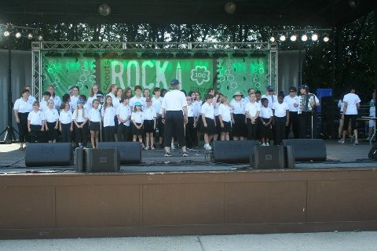

If you love to sing, this is the activity for you. We sing at nursing homes, festivals, area malls, Girl

Scout activities, parades, sports events, and more. Open to girls and adults of all ages. Come join us as we “Make New Friends” through music!

We’ll be rehearsing once a month, Sundays, **January 8, February 12, March 5, and April 2, 2017:**

* Peterson Center (Camp Ilchester, Ellicott City) with 1st and 2nd year Chorus members from 2-3:30 and experienced Chorus members (3rd year and older plus Trefoil singers) from 3-4:30 PM
* 6:00-7:00 PM in Harford County

Christ our King Presbyterian, 10 Lexington Rd., Bel Air

Come to whichever rehearsal is convenient for YOU!

Cost: $10 for the year covers rehearsals, patch,

and Chorus polo shirt.

Either bring registration below to your first rehearsal or mail registrations for each Scout to:

Kelly Smith

209 Kenwood Avenue

Baltimore, MD 21228

Questions? Call Pat Disharoon at 410-233-5337

E-mail GSCMChorus@yahoo.com

Check our website: www.gscmchorus.org



------------------------------------------------------------------------------------------------------------------------------------------------------

Name: ______________________________ E-mail?____________________________

Telephone: __________________________Shirt size: Child S M L Adult S M L XL 2X

Address: ________________________________________________

Girl Scout Program level: (Circle one) D Br Jr Cad Sr Ambassador Adult

____ I would also like to purchase a forest green Chorus jacket at $30; payment enclosed.

I give permission for my daughter to attend the Girl Scout Chorus, both performances and rehearsals. Should another adult accompany my daughter on this activity, she will have permission to act on my behalf in an emergency situation.

Parent/Guardian name (print): ____________________________________

Signature: ______________________________ Date: _______________



If you love to sing, this is the activity for you. We sing at nursing homes, festivals, area malls, Girl

Scout activities, parades, sports events, and more. Open to girls and adults of all ages. Come join us as we “Make New Friends” through music!

We’ll be rehearsing once a month, Sundays, **January 8, February 12, March 5, and April 2, 2017:**

* Peterson Center (Camp Ilchester, Ellicott City) with 1st and 2nd year Chorus members from 2-3:30 and experienced Chorus members (3rd year and older plus Trefoil singers) from 3-4:30 PM
* 6:00-7:00 PM in Harford County

Christ our King Presbyterian, 10 Lexington Rd., Bel Air

Come to whichever rehearsal is convenient for YOU!

Cost: $10 for the year covers rehearsals, patch,

and Chorus polo shirt.

Either bring registration below to your first rehearsal or mail registrations for each Scout to:

Kelly Smith

209 Kenwood Avenue

Baltimore, MD 21228

Questions? Call Pat Disharoon at 410-233-5337

E-mail GSCMChorus@yahoo.com

Check our website: www.gscmchorus.org



------------------------------------------------------------------------------------------------------------------------------------------------------

Name: ______________________________ E-mail?____________________________

Telephone: __________________________Shirt size: Child S M L Adult S M L XL 2X

Address: ________________________________________________

Girl Scout Program level: (Circle one) D Br Jr Cad Sr Ambassador Adult

____ I would also like to purchase a forest green Chorus jacket at $30; payment enclosed.

I give permission for my daughter to attend the Girl Scout Chorus, both performances and rehearsals. Should another adult accompany my daughter on this activity, she will have permission to act on my behalf in an emergency situation.

Parent/Guardian name (print): ____________________________________

Signature: ______________________________ Date: _______________