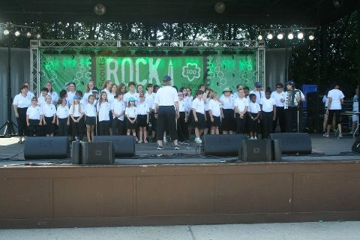

If you love to sing, this is the activity for you. We sing at nursing homes, festivals, area malls, Girl

Scout activities, parades, sports events, and more. Open to girls and adults of all ages. Come join us as we “Make New Friends” through music!

We’ll be rehearsing twice in groups in October:

Sundays, October 9 and 23:

* Peterson Center (Camp Ilchester, Ellicott City) with 1st and 2nd year Chorus members from 2-3:30 and experienced Chorus members from 3-4:30 PM
* 6:00-7:00 PM at another location TBD

We’ll all get together to rehearse, making music together, on November 11, at the Peterson Activity Center at Camp Ilchester. Arrive by 7 PM. We can sing, enjoy some eats, and those who desire can spend the night.

Cost: $10 for the year covers rehearsals, patch,

snacks and meals, and Chorus polo shirt.

Please mail registrations for each Scout to:

Kelly Smith

209 Kenwood Avenue

Baltimore, MD 21228

Questions? Call Pat Disharoon at 410-233-5337

E-mail PDisharoon@aol.com

Check our website: www.gscmchorus.org



-----------------------------------------------------------------------------------------------------------------------------------------------------

Name: ______________________________ E-mail?____________________________

Telephone: __________________________ Shirt size: Child S M L Adult S M L XL 2X

Address: ________________________________________________zip__________

Girl Scout Program level: (Circle one) D Br Jr Cad Sr Ambassador Adult

____ I would also like to purchase a forest green Chorus jacket at $30; payment enclosed.

I give permission for my daughter to attend the Girl Scout Chorus, both performances and rehearsals. Should another adult accompany my daughter on this activity, she will have permission to act on my behalf in an emergency situation.

Parent/Guardian name (print): ___________________________________

Parent/Guardian signature: _______________________________ Date: ____________